Islamic University,Bangladesh
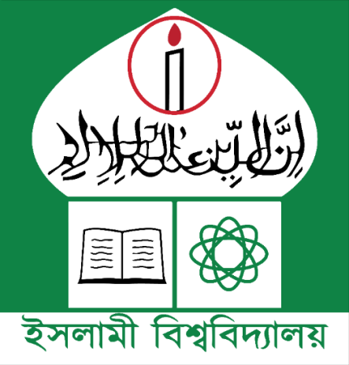
Department of
INFORMATION & COMMUNICATION TECHNOLOGY

Report On
Course No: ICT-3102
Course Title: Wave Propagation and Antenna Laboratory
Submitted to:

Dr. Tarek Hasan Al Mahmud

Professor

Information and Communication Technology

Islamic University, Kushtia.

Submitted by:
Name: Md. Moshiur Rahman
Roll: 2118005
Reg. No: 1297
Session: 2021-2022

